CA0 of Atmospheric Thermodynamics

Student: 甘祐銓

ID: B11209013

Department: 大氣一

By the equation given in the topic:

$$θ=T{\left(\frac{P_{0}}{P}\right)}^{\frac{R_{d}}{C_{p}}}$$

By importing the data that is given, we can calculate for the potential temperature.

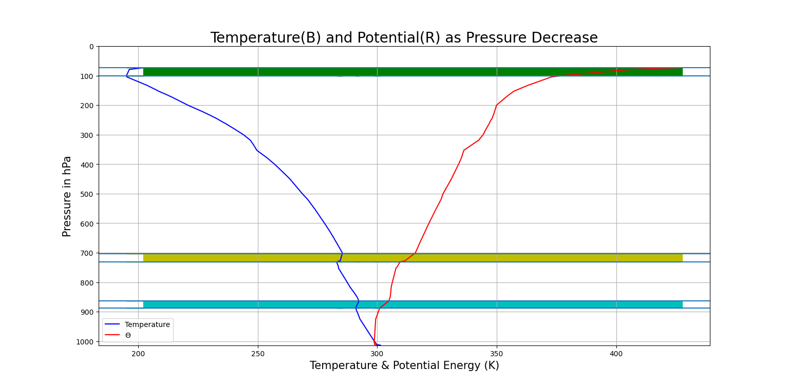Based on the data, we can get the plot below.

As the pressure decrease, the temperature decreases, but the potential energy is increased.

The dark blue, orange part of the plot are the inverse layer in the troposphere. The green part is above the tropopause.

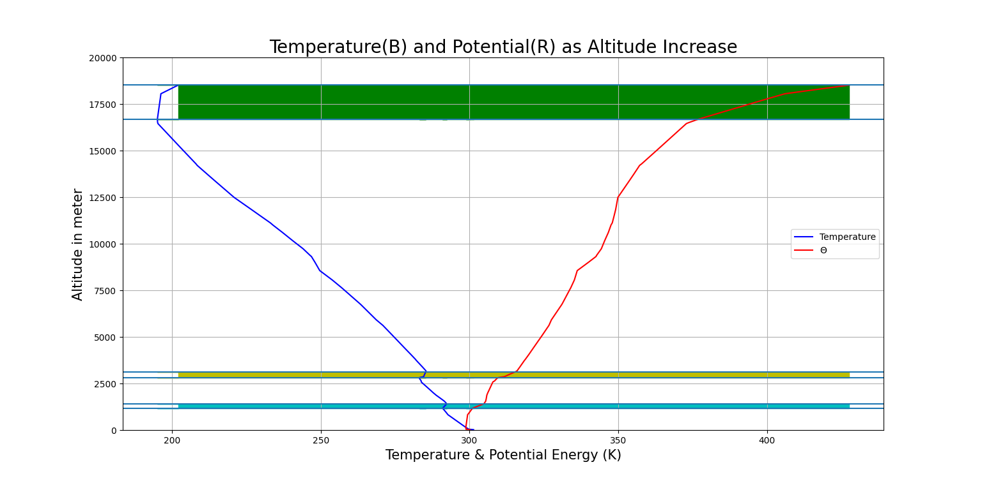

The plot is temperature and potential temperature as altitude increasing.

The dark blue, orange parts of the plot, is the inverse layer in the tropopause.

The green part is in the stratosphere.